2025 TERM I MZIMBA NORTH DISTRICT EXAMINATIONS

PHYSICS FORM 4
PAPER I
(100 MARKS)
Date: Thursday, 11 December 2025
Time Allowed: 2hrs
7.30 am to 9.30am

INSTRUCTIONS:
- This paper contains 11 printed pages. Please check.
- This paper has two sections: A, and B
- The maximum number of marks for each answer is indicated against each question.
- Write your answer in the spaces provided on the question paper.
- Scientific calculators may be used.
- All working must be clearly shown
- Hand in your question paper to the invigilator when time is called to stop writing.

@MZN-T1-2025
SECTION A
- a. Give any two examples of systematic error
________________________________________________________________________________________________________________________________________________________
(2 marks)
b. State the kinetic theory of matter
________________________________________________________________________________________________________________________________________________________
(1 mark)
c. figure 1 below is a measuring instrument
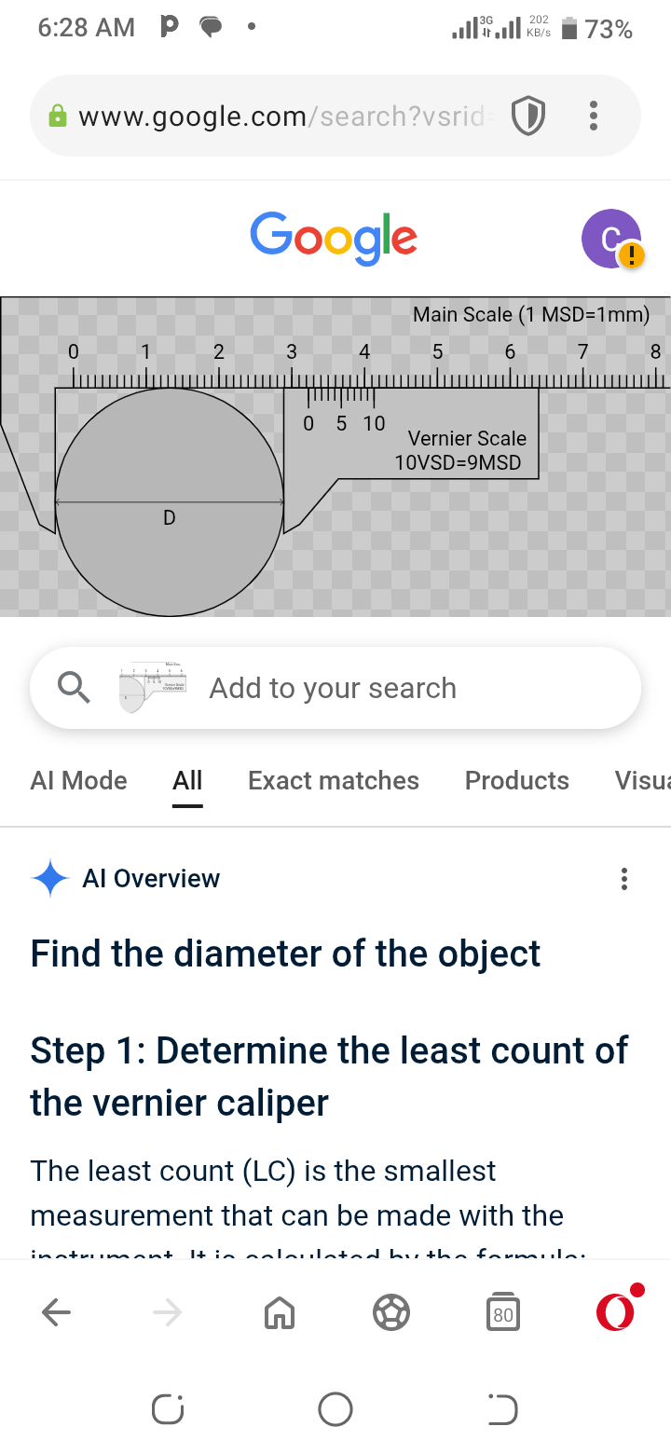

- What is the advantage of using this instrument

________________________________________________________________________________________________________________________________________________
(1 mark)
- Calculate the size of the object being measured on the instrument

(3 marks)
- a. Describe how Thermal expansion is applied in the following;
i. Tooth filling
______________________________________________________________________________________________________________________________________________________ (2 marks)
ii. Metal riveting
__________________________________________________________________________________________________________________________________________________________________________________________________________________________________________

(2 marks)
b. Derive the formula F = ma

(3 marks)
- a. The figure below is a Light wave passing through two gaps on a barrier
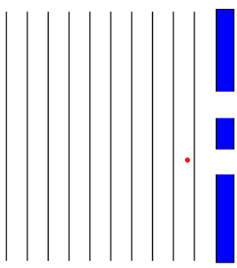

- On the same diagram, complete the wave to show how the wave is going to emerge on the other side of the diagram
(2 marks)
- What two properties of waves is shown on the completed diagram.
____________________________________________________________________________________________________________________________________
(2 marks)
b. Figure below is a diagram of a pulley system being used to lift a 30kg mass through a vertical height of 3m when an effort of 60N is applied. Use it to answer questions that follow:

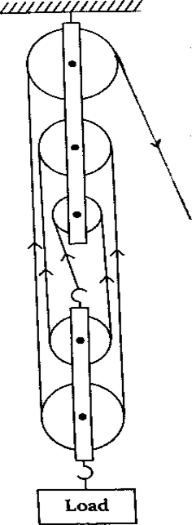

- Work out the efficiency of a machine.

- marks)
- a. Differentiate speed from velocity.
__________________________________________________________________________________________________________________________________________________(1mark)
b. A 25kg body moving with velocity of 10m/s collides with a 7kg body moving in the same direction with velocity of 6m/s along the same path. If the two bodies join together on impact, find their common velocity.

(3 marks)
c. Describe using the Kinetic theory of matter how the sweet aroma of flied fish from the Kitchen reaches the sitting room of a house.
__________________________________________________________________________________________________________________________________________________________________________________________________________________________________________
- marks)
- a. State hook’s law
________________________________________________________________________________________________________________________________________________
(1 mark)
b. Figure below shows a spring combination. Use it to answer questions that follow.
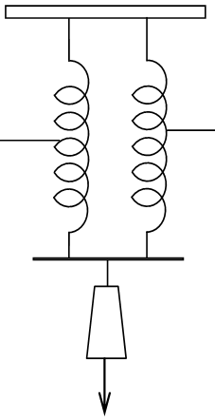
60kg

- State the type of spring combination above.
_______________________________________________________________
- marks)
- Calculate the extension if the system has identical springs. (Take 2N/m as the springs coefficient of elasticity

(4 marks)
c. Give any one difference between heat and temperature
_____________________________________________________________________________________________________________________________________(1mark)
- a. Define pressure
________________________________________________________________________________________________________________________________________________
(1 mark)
b. Calculate the pressure exerted by a column of a liquid at the base of a container if the density of a liquid is 13600 kg/m³ and its depth is 0.1 m. (g = 10 m/s²).

(3 marks)
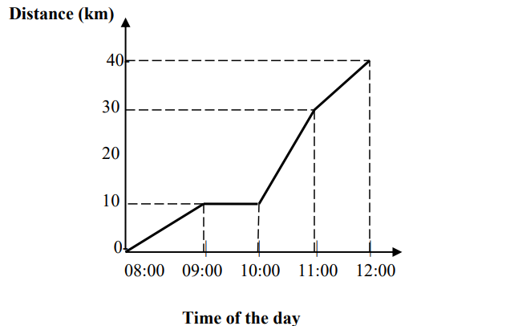
c. The figure below is a distance – time graph of an object

- Calculate the speed of an object during the first 1 hour

(3marks)
- a. Figure below shows a glass flask fitted with a balloon. Use it to answer questions that follow.

    - What happens to the balloon when the water bath is heated.
___________________________________________________________(1 marks)
    - Explain your answer to the answer above (i) in terms of the kinetic theory of matter.
____________________________________________________________________________________________________________________________________________________________________________________________________________________________________________________________________________________________________________________________________________________________________________________________________________
(4marks)
b. Give any two advantages of using alcohol thermometer over mercury thermometer.
________________________________________________________________________________________________________________________________________________________________________________________________________________________________________________________________________________________________
(2 marks)
- a. State Boyles law
________________________________________________________________________________________________________________________________________________
(1 mark)
b. A tyre has a volume of 0.055 m³ and contains air at a pressure of 145 Pa and a temperature of 280K. What temperature does the tyre have if its pressure is to be increased to 196 Pa assuming the volume of the tyre has increased to 0.52 m³?

(3 marks)
c. State the law of conservation of linear momentum
________________________________________________________________________________________________________________________________________________
(1 mark)
d. Give any two applications of circular motion
________________________________________________________________________________________________________________________________________________
(2 marks)
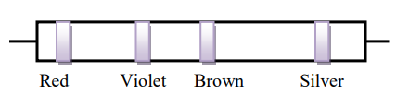
- a. The figure below is a diagram of a color code resistor

- Find the resistance of the resistor

- marks)

b. An electrical heater is rated at 200 W. If electrical energy costs K28.00 per kWh,
what is the cost of using this heater for 8 hours at its maximum power?

(4 marks)
- a. State Newton’s third law of motion
________________________________________________________________________________________________________________________________________________
(1 mark)
b. Explain how swimming is made possible
________________________________________________________________________________________________________________________________________________________________________________________________________________________
(3 marks)
b. Calculate the work done if an object of mass 20kg is lifted 10m

(3 marks)
SECTION B (30 MARKS)
- a. Figure below is a graph showing behavior of water as temperature changes.
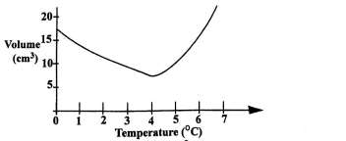
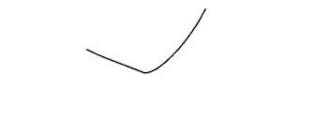
volume

density

- Explain how this behavior of water makes the survival of aquatic life possible
__________________________________________________________________________________________________________________________________________________________________________________________________________________________________________________________________________________________________________________________________________________________________________________________________________________________________________________________________________________________________________________________________________________________________________________________________________________
(5 marks)

b. Explain how a falling object in air reaches terminal velocity
________________________________________________________________________________________________________________________________________________________________________________________________________________________________________________________________________________________________________________________________________________________________________________________________________________________________________________________________________________________________________________________________________________________________________________________________________________________________________________________________________________________________________________________________________________
(5 marks)
- a. With the aid of a labelled diagram, describe how a liquid in a glass thermometer work

________________________________________________________________________________________________________________________________________________________________________________________________________________________________________________________________________________________________________________________________________________________________________________________________________________________________________________________________________________________________________________________
(7 marks)

b. Explain why dams are constructed thicker at the bottom
________________________________________________________________________________________________________________________________________________________________________________________________________________________
(3 marks)
- a. with the aid of the diagram, describe how a destructive interference of waves occurs in water wave.

_____________________________________________________________________________________________________________________________________________________________________________________________________________________________________________________________________________________________________________________________________________________________________________________________________________________________________________________________________________________________________________________________________________
(5 marks)
b. Design an experiment which could be used to find the speed of sound in air using an
echo.
_______________________________________________________________________________________________________________________________________________________________________________________________________________________________________________________________________________________________________________________________________________________________________________________________________________________________________________________________________________________________________________________________________________________________________________________________________________________________________________________________________________________________________________________________________________________________________________________________________________________________________________________________________________________________________________________________________________________________________________________________________________________________________________________________________________________________________________(5 marks)

END OF THE QUESTION PAPER

